IT3212 Høst 2025

Øving 1: Data Preprocessing

Gruppenummer: 37
NTNU epost | Etternavn | Fornavn
oddvarhf@stud.ntnu.no | Oddvar | Hanevik Folkestad
@stud.ntnu.no
@stud.ntnu.no
@stud.ntnu.no

Øving 1: Data Preprocessing 1
Task 1 2
Task 2) 8
Task 3) 8
Task 4) 13
Task 5) 14
Task 6) 14

Task 1

A)
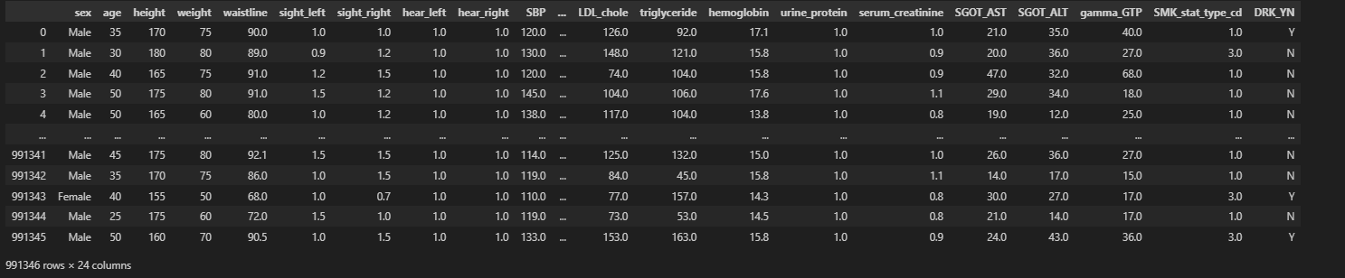
Figure 1. Displaying the first few rows

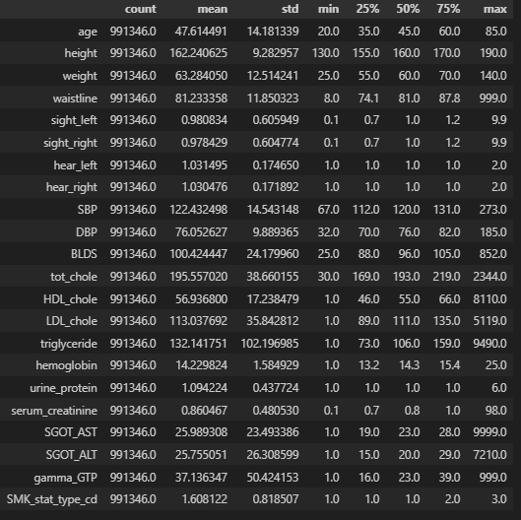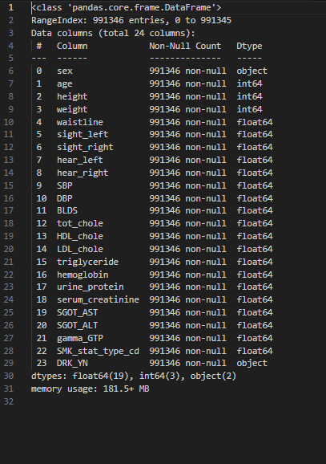
Figure 3. Data types of each column

Figure 2. Summary statistics

Here I’ve only used standard pandas (pd) methods such as describe, info, and print.

B)
Figure 4. Identify missing values

We can see in Figure 4 that we do not have any missing values in our dataset. (The code is included so you can see that it was done correctly.)

When checking the dataset we found duplicates (np.duplicated()). We found that there are a small number of rows that are completely identical across all variables. In practice, it is extremely unlikely that two different individuals would have exactly the same values for every single measurement (blood pressure, cholesterol levels, eyesight, hearing, etc.). Therefore, such duplicates are most likely the result of double registrations in the dataset (extremely unlikely). Since duplicates would otherwise cause some data points to be weighted more heavily than others, we removed them as cleaning. If the data included a time stamp for the test we would know for sure.
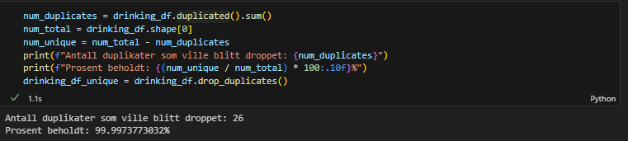
Figure 6. Identify duplicated values

To identify potential outliers, we visualized the features using boxplots and histograms. We can observe that several biochemical variables (triglycerides, blood sugar, and liver enzymes) contain extreme values, while anthropometric variables (height and weight) also display outliers that are likely to represent real individuals. These findings will be considered further in the outlier handling step.
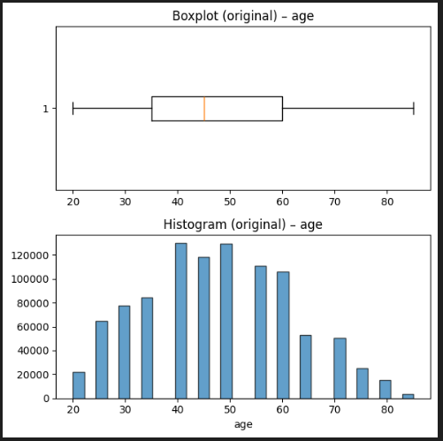  The age variable is distributed mainly between 20 and 80 years, with no extreme outliers present. The histogram shows a fairly even spread across this range. | 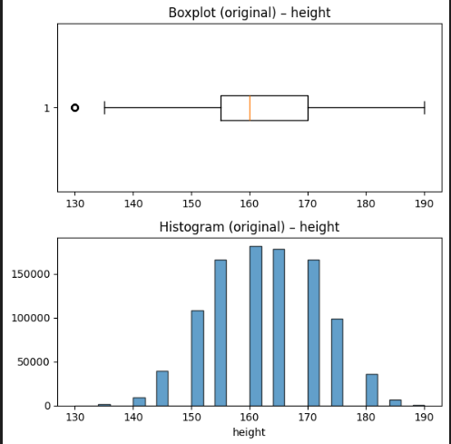 Height is normally distributed around 160–170 cm. The boxplot shows a few lower outliers (around 130 cm), which likely represent shorter individuals rather than data errors. | 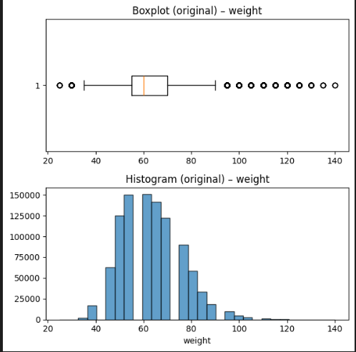  Weight is centered around 60–70 kg, with a tail extending towards higher values. The boxplot identifies several outliers above 100 kg, which represent overweight and obese individuals.
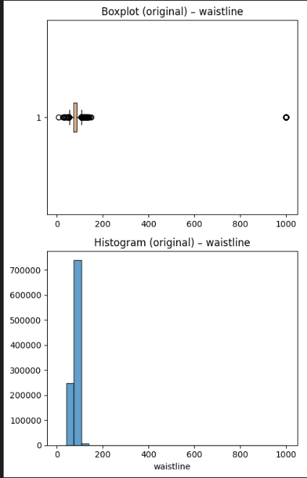  The waistline variable shows a strong concentration of values in a realistic range (around 70–100 cm), but the boxplot also reveals extreme outliers, including values above 1000 cm, which are clearly unrealistic (I looked up the world record and it 302cm so clearly this is a typo of some sort) | 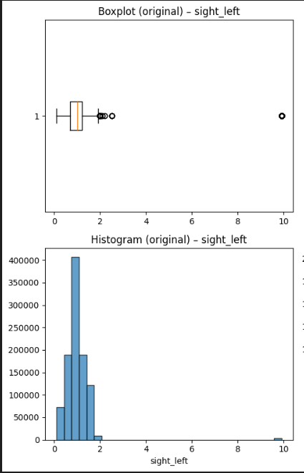  The sight_left is measured on a scale from 0.1 to 9.9, where lower values indicate better vision and 9.9 is blindness. As we can see in the distribution, most values cluster close to 1.0, but there are also individuals coded with 9.9, meaning that blind persons are included in the datase | 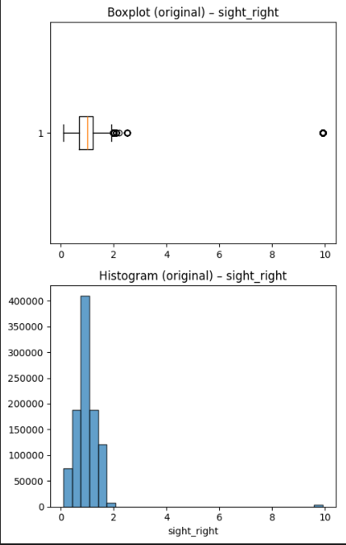  Same as sight_left but for other eye
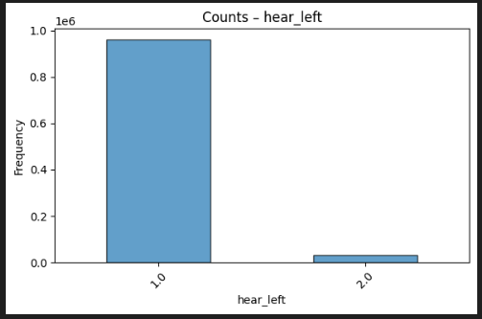  The variable hear_left is recorded as 1 = normal hearing and 2 = abnormal hearing. This shows that almost all individuals have normal hearing (1), with a small group coded as 2. These values are discrete | 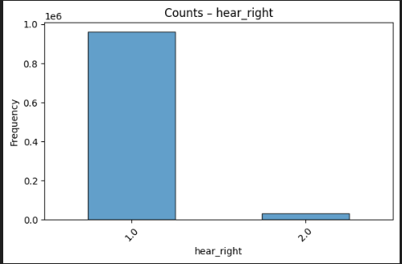  Same as hear_left | 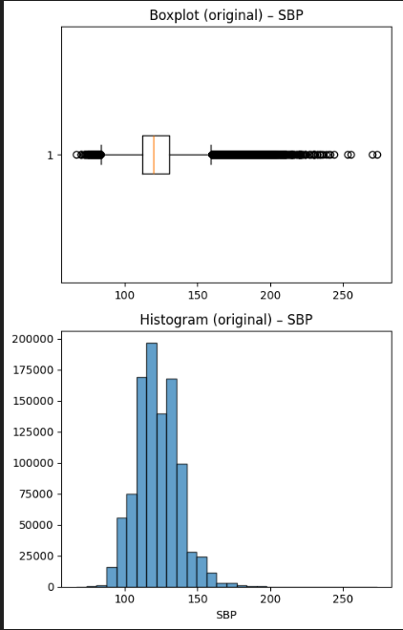  Systolic blood pressure is centered around 120 mmHg, but the boxplot shows numerous outliers at both the low and high ends.
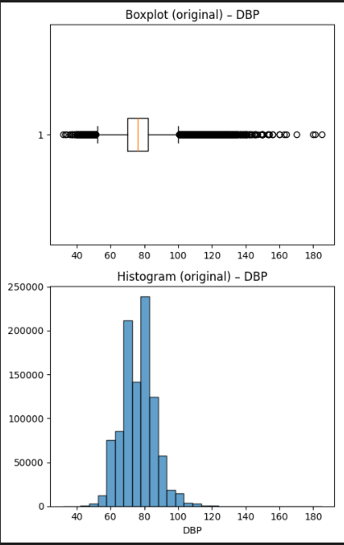  The diastolic blood pressure values are centered around 70–85 mmHg, which is the expected physiological range. The boxplot shows outliers both on the low side and the high side | 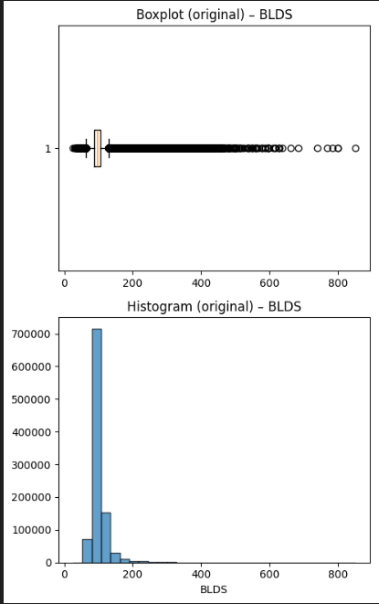  Blood sugar levels are right-skewed, with most individuals clustering around 90–100 mg/dL. The histogram and boxplot reveal many extreme outliers above 200 mg/dL, which could represent diabetic patients | 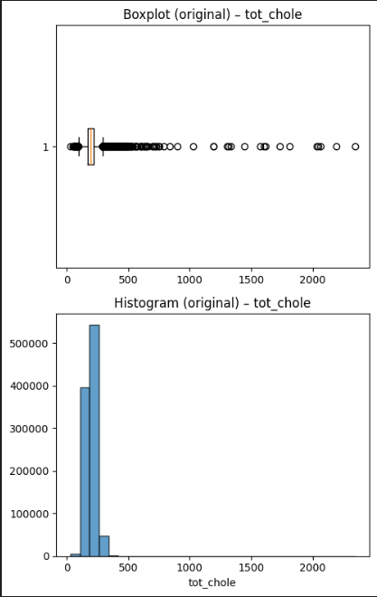  Total cholesterol is typically distributed between 150–220 mg/dL.
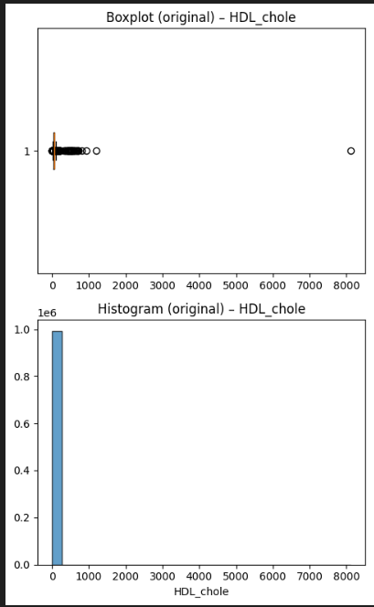  Most values for HDL cholesterol are in the expected range of 40–60 mg/dL. | 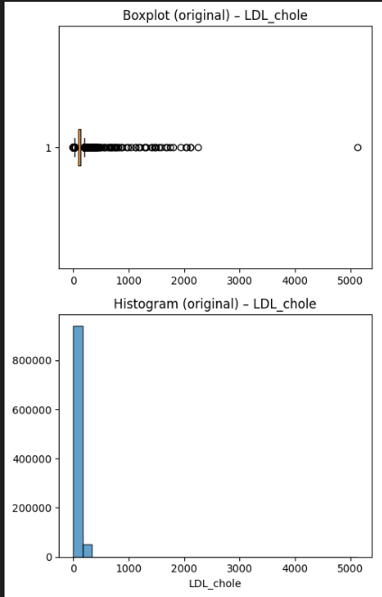  DL cholesterol is typically distributed between 100–160 mg/dL. but the boxplot highlights extreme outliers above 1000 mg/dL and even exceeding 5000 mg/dL, which is pretty extreme | 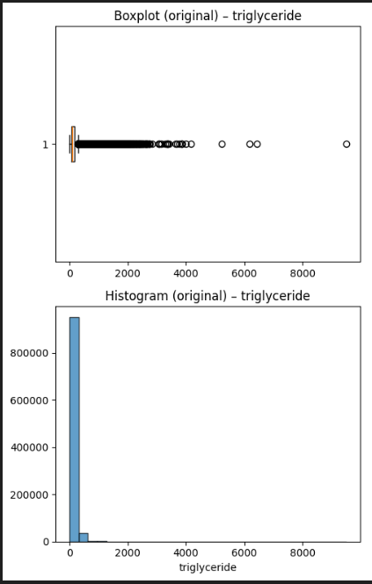  Triglyceride levels are strongly right-skewed, with most values below 200 mg/dL.
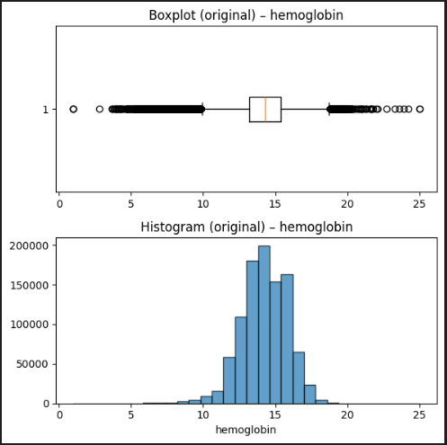  Hemoglobin levels are centered around 13–15 g/dL | 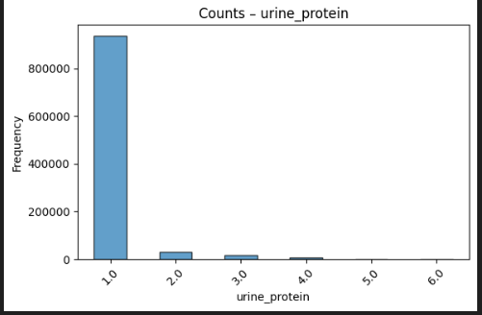  Urine_protein is an ordinal variable measured on a discrete scale from 1 to 6. The histogram shows that most individuals fall at 1, with progressively fewer in higher categories. These values are categorical | 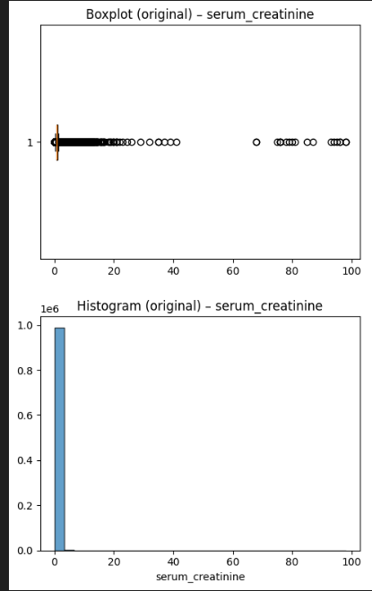  Serum creatinine is highly right-skewed. Most values fall within the expected range (0.6–1.2 mg/dL), but the boxplot highlights extreme outliers above 20 mg/dL and even up to ~100 mg/dL.
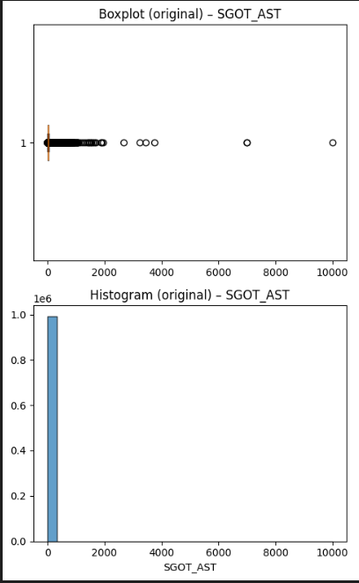  SGOT_AST values are concentrated under 40 IU/L | 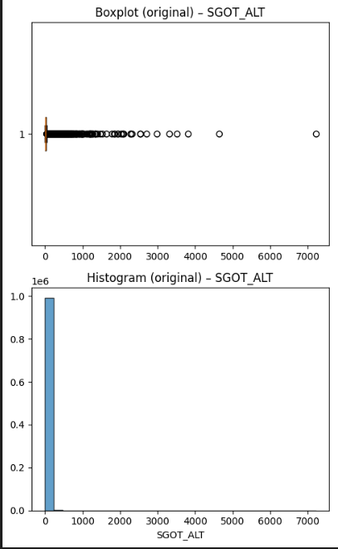  The distribution of SGOT_ALT is similar to SGOT_AST, with most values below 40 IU/L and a large number of right-skewed outliers | 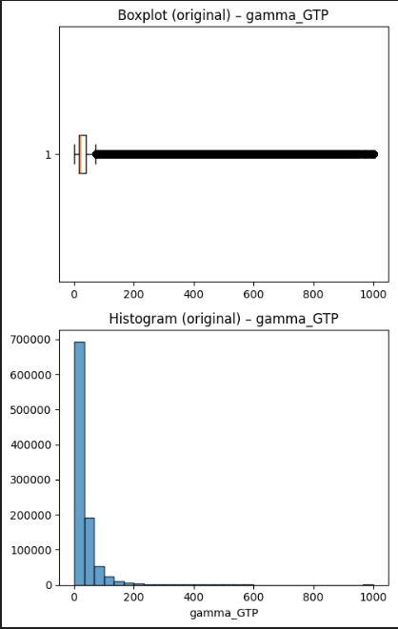  Gamma_GTP is highly right-skewed, with most values under 60 IU/L
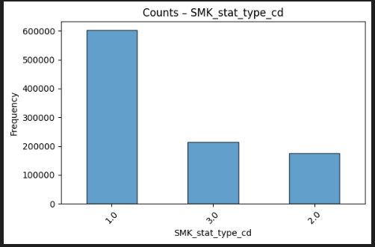  The smoking status variable (0 = never smoked, 1 = quit, 2 = current smoker) shows that most individuals have never smoked, while smaller groups are former or current smokers | 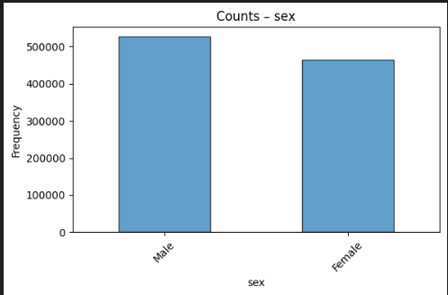  The sex variable is almost evenly distributed between males and females

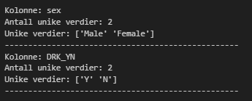
Figure 7. Unique values in categorical sex and D columns. Sex and the target (drinking; yes or no)
values

Figure 8. Numerical and categorical Columns
values

Based on the bar plots shown above (SMK_stat_type_cd is coded as 0 (never smoked), 1 (quit), and 2 (current smoker) and figure 7 and 8, we can observe the unique values in the categorical columns.

Task 2)

a)

(Her må vi legge til hva vi hadde gjort om vi fant missing valus, det er viktig, spurte han om det, skriv om det her utdypende)

Task 3)

We did not remove outliers from categorical variables. Unlike continuous data, categorical features consist of a fixed set of valid classes, so rare values do not represent measurement errors but real subgroups (abnormal hearing, blindness, severe proteinuria, smoking status). To support this we can calculate conditional probabilities of drinking given each category, and found that some categories are strongly associated with drinking behavior (for example, current smokers had a much higher probability of drinking than never-smokers). categorical ‘outliers’ capture meaningful variation. Removing them would discard valuable predictive information and could introduce bias. Therefore was all categorical values even «outliers» retained. But we also need to think about the small amount of data some of these categorical values have.
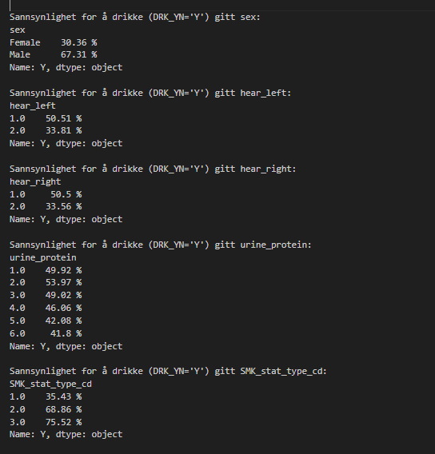
Figure 8. conditional probabilities
values

For numerical variables, we applied a log transformation (we have non negative on no 0 values in data) to those with skewed distributions in order to normalize them. We can se in figure 9 that this makes them normally distributed (some you need to squint your eyes), but data that is allerdy normally distributed we don’t use log (age height, weight, hemoglobin etc). Log reduces the influence of extreme values and makes the data more suitable for statistical methods that assume normality (z score). After transformation, we applied the z-score method to identify outliers across all continuous variables. Values with |z| > 3 were considered potential outliers. This approach ensures consistency across variables while still accounting for skewness in the data. You can see the results in figure 10.
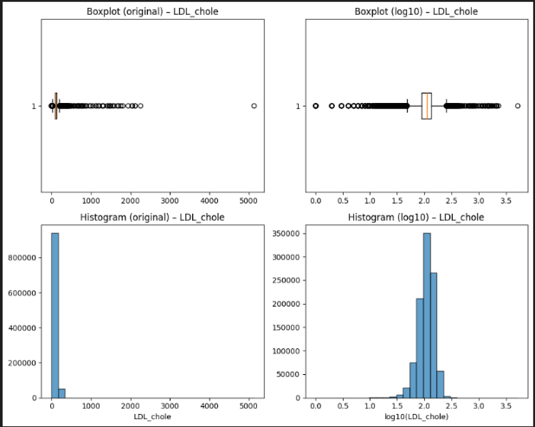
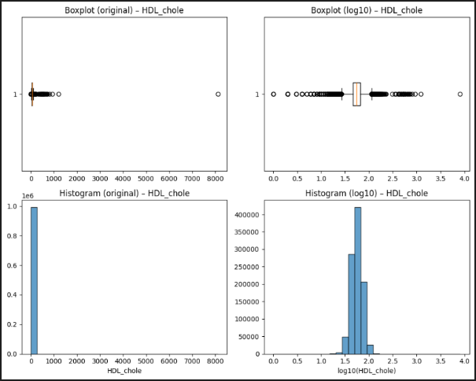
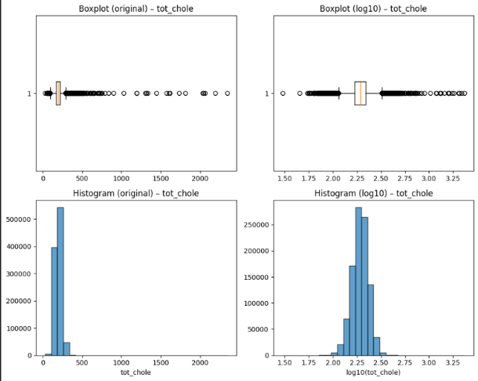
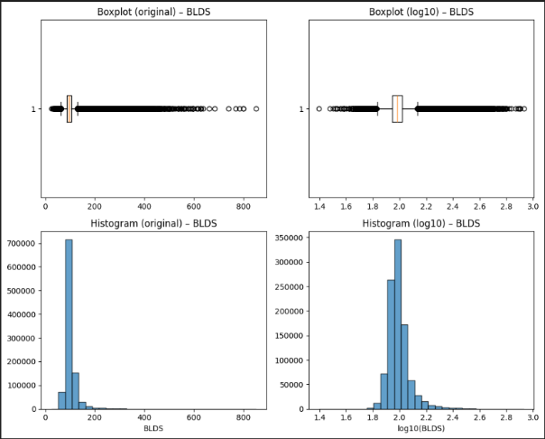
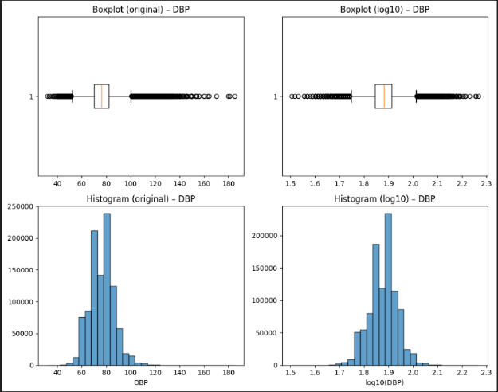
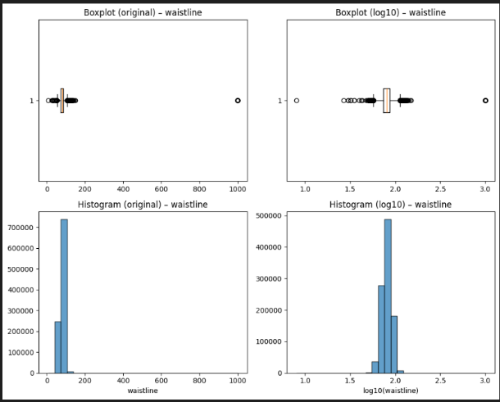
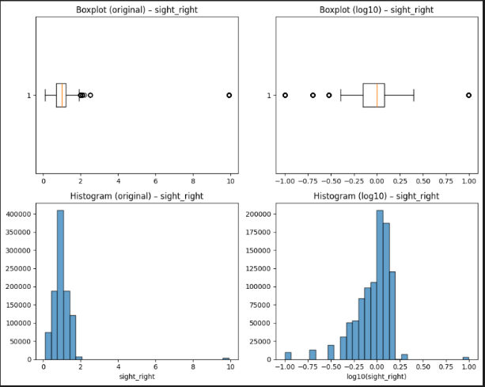
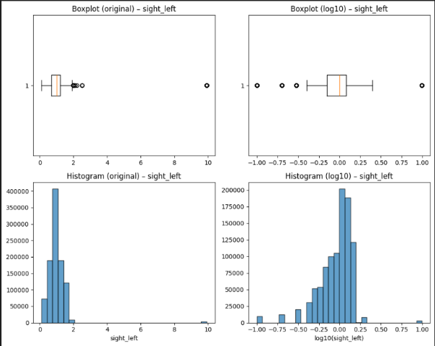
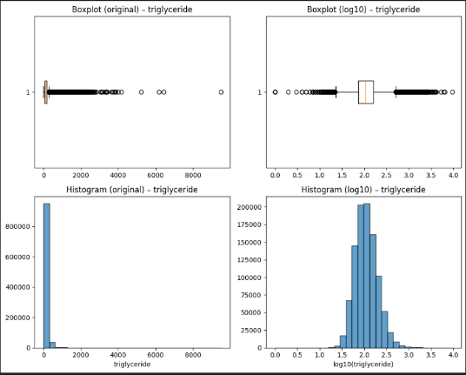
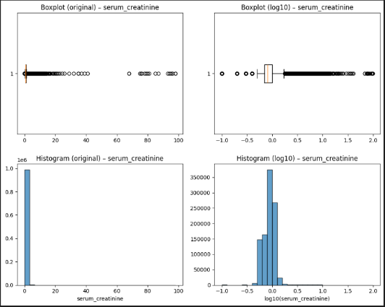

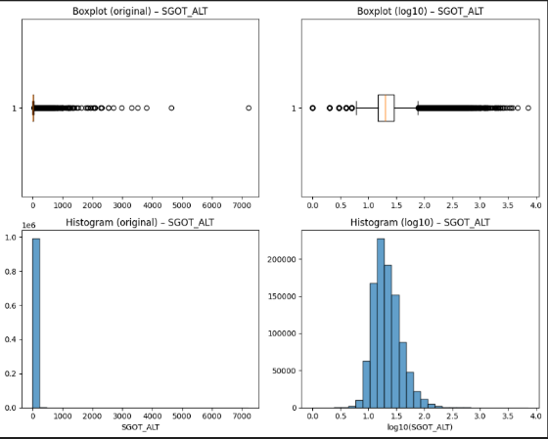
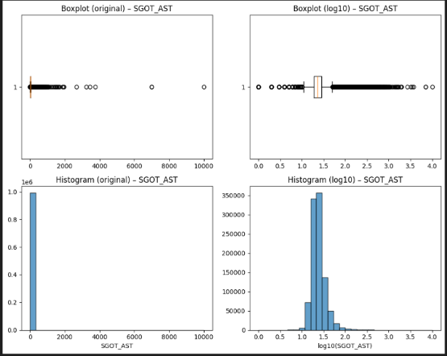

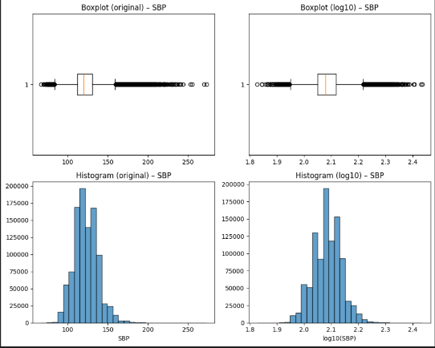
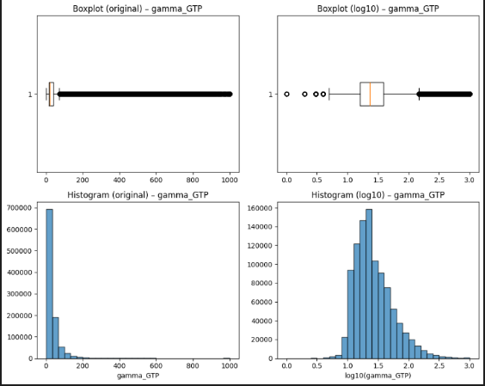
Figure 9. log transformed data
values

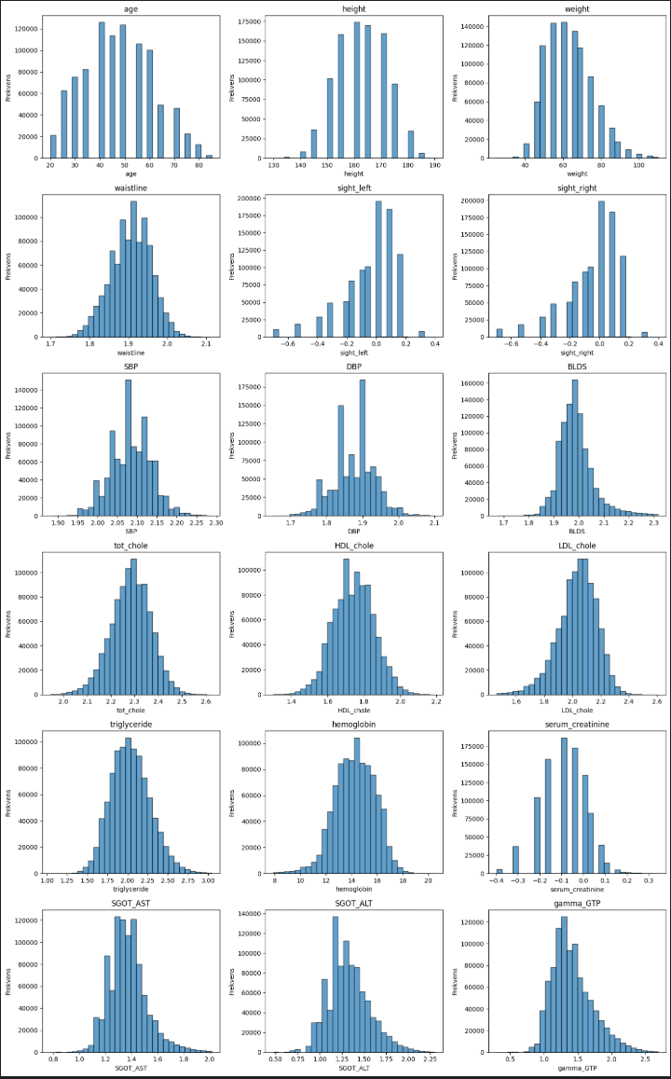
Figure 10. data after removing outliers
values

Task 4)

A)
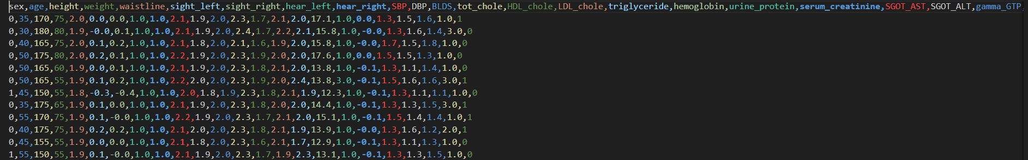
Figure 11. Encoded data
values

For encoding categorical variables, only sex and the target variable DRK_YN required transformation, since the other categorical variables in the dataset were already stored as numerical values. We applied binary encoding: Male = 0, Female = 1 for sex, and Non-drinker = 0, Drinker = 1 for DRK_YN. This approach is appropriate because both variables are binary and do not require one-hot encoding. Keeping the encoding simple without introducing unnecessary additional features. You can se the result in figure 11.

B)
Feature scaling was applied to all numerical variables (excluding the target). We used Min-Max scaling to ensure that variables are on a comparable scale. Since the dataset was log-transformed and outliers were removed, the feature ranges are no longer distorted by extreme values, making Min-Max scaling particularly appropriate. This step is necessary because many machine learning algorithms are sensitive to differences in magnitude between features. By scaling the features, we prevent variables with larger numeric ranges from dominating the model (For example, if a model is trained with both age and annual income, income would dominate simply due to scale)
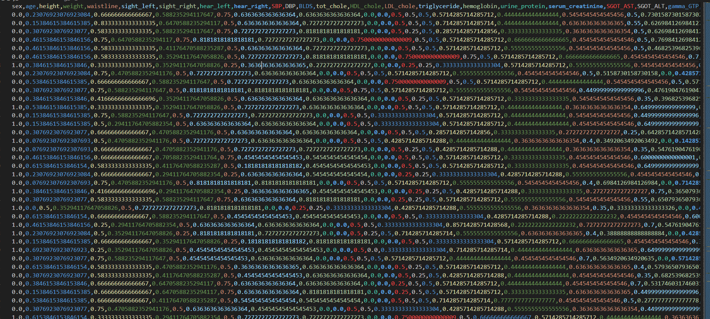
Figure 12. Min-Max used on data
values

Task 5)

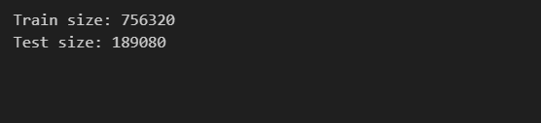
Figure 13. splitted data
values

To doo skriv hvorfor slitting er viktig!!!

Task 6)
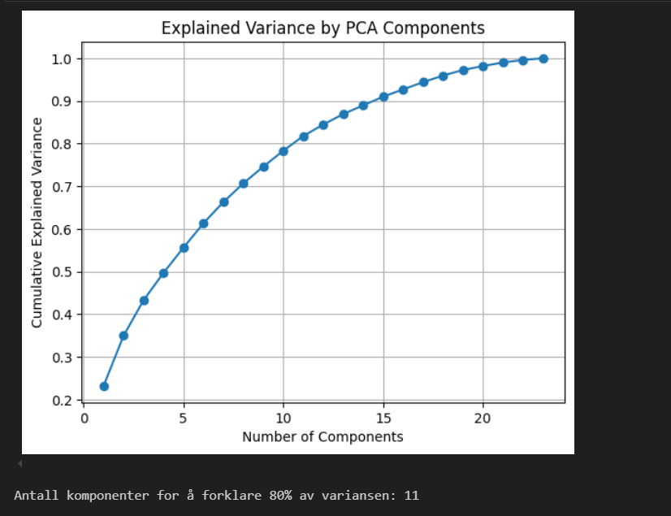
Figure 14. Variance by PCA plot
values

As we can see in the figure 14, we only need 11 components to describe about 80% of the variance in the dataset. We could include more components, but the returns diminish – the curve follows a logarithmic-like shape, meaning that adding extra components explains less and less additional variance. Since our goal with PCA is to reduce dimensionality while preserving as much information as possible, using more than 11 components gives little benefit. If we instead aimed for 90% explained variance, we would need around 15 components. Here we chose 11 components, since this strikes a good balance between model simplicity and information retention.
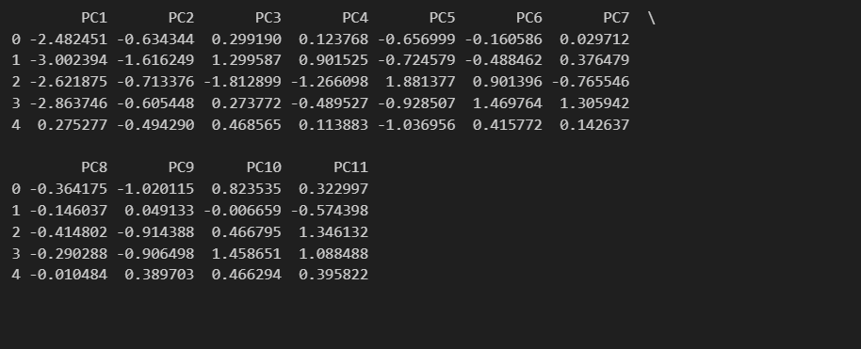
The table shows the transformed dataset after applying PCA with 11 components’
Vi må utdype hvordan det påvirker data

